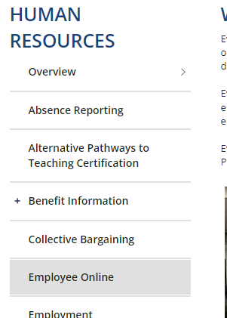
https://employeeonline.everett.k12.wa.us/employeeonline
DEPARTMENTS → HUMAN RESOURCES → EMPLOYEE ONLINE
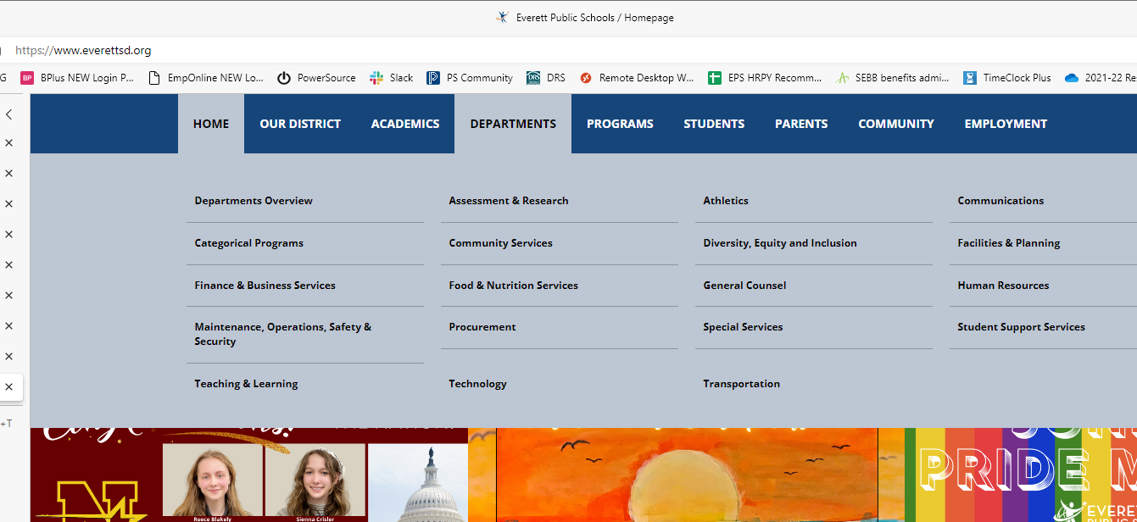

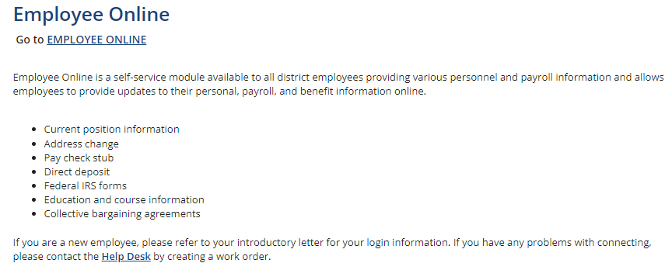
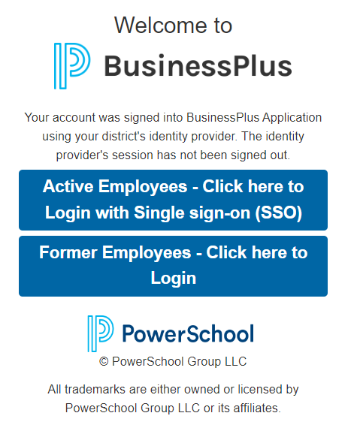
If you are accessing outside of the district network (i.e. from home) you will be asked to enter your district-issued network id (your employee id number) and password.

